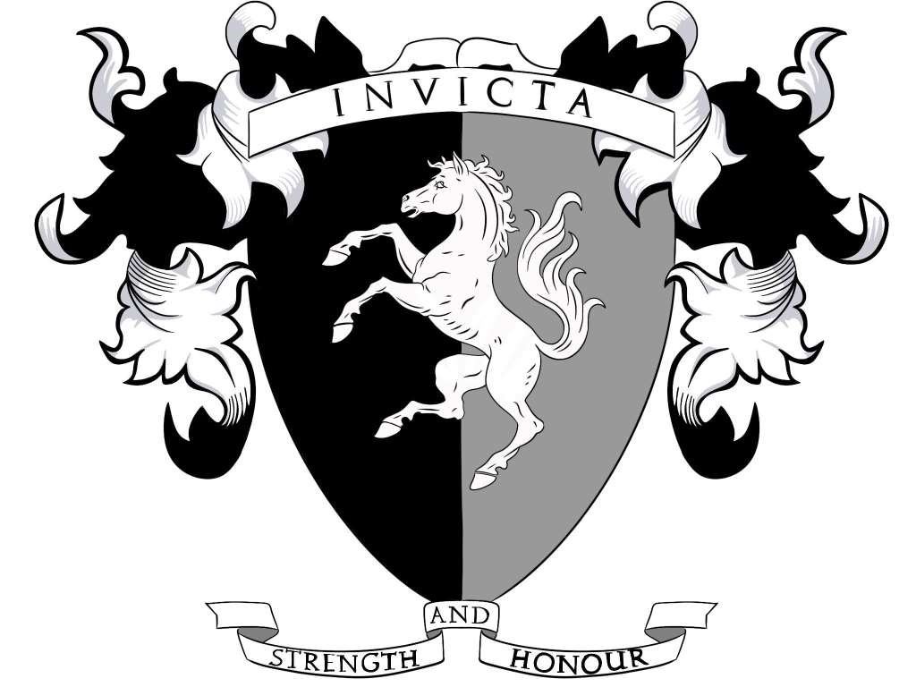

Invicta PR event policy

Objective: Maximise exposure of the sport and optimise the traffic driven to the club’s social media sites to grow the sport.

If you are attending a public event as support crew, fighter, or guest of the club and there is a notable person attending the event and engaging with Invicta and you have images, or video footage, of the engagement, then you must seek approval from the social media manager of the presidium, or another member of the presidium to publish the image on your personal social media account.

In the first instance Invicta would expect to post images from the club’s own social media accounts always giving credit and tag the account of the person who took the picture or video.
Once initial image has been posted, the image can be shared (club preference) or posted from your own social media account.

If you are posting from a social media platform where Invicta does not have presence, please tag BuhurtInternational and MCSA, the event, and the event organiser.

